**DataViz Queries (SQL, POWER-BI, LOOKER STUDIO)**

The projects involved connecting with the servers, performing data cleaning using Power Query, and creating measures and relationships between tables to develop key performance indicators (KPIs). Subsequently, visually appealing dashboards were created on Looker Studio (Google) and Power BI platforms.

**PROJECT 1 (Income Café Dashboard – Power Bi)**

A dashboard based on a café's database was requested to maintain control over its revenues. To achieve this, tasks were performed, including data extraction from an external SQL server, data cleansing, creation of relational tables, and DAX measures. The resulting dashboard features four interrelated charts, allowing for dynamic navigation by selecting any element to filter related values.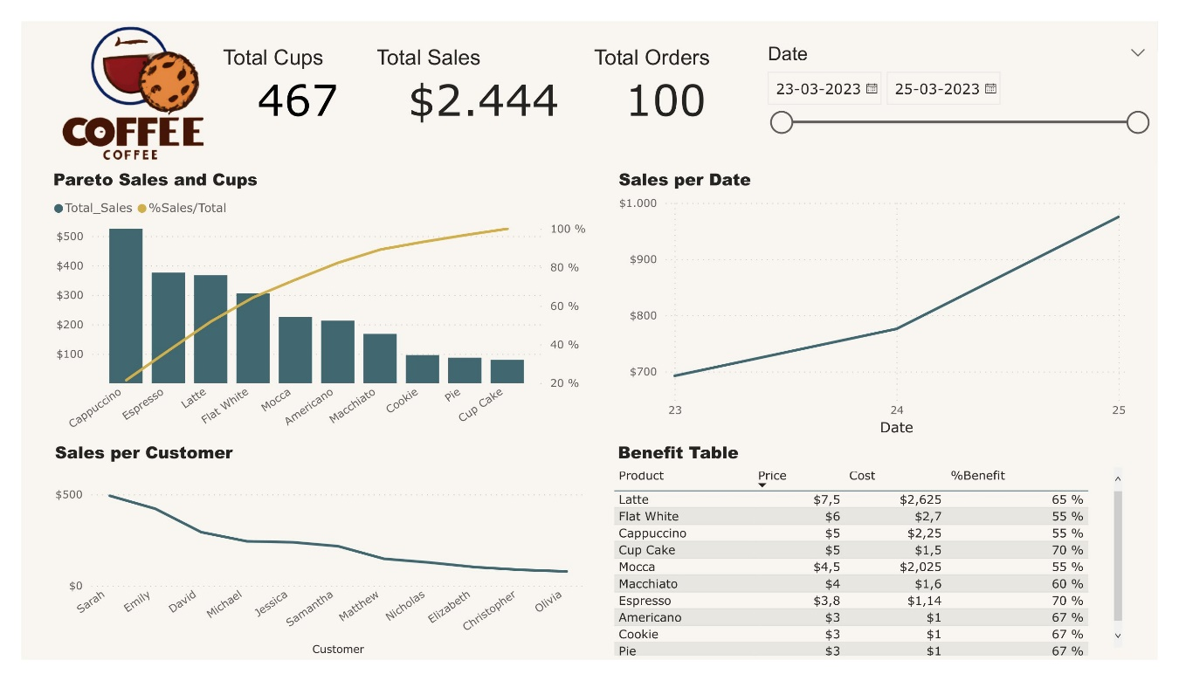

**Here are the questions I was interested in answering**

Which key performance indicators (KPIs) are of interest to the client?

Which tables need to be queried from the server to build the dashboard?

How can I create an environment for easy, daily updates in PowerBI?

How should I adjust variables to relate tables and create measures in Power Query?

What is the best way to arrange charts and select colors for a compelling visualization?

**I took the following steps to create my analysis**

Established connections with relevant information sources (SQL Server)

Performed data cleansing using the most suitable environments, such as Power Query.

Related tables and developed the necessary indicators.

Selected appropriate charts, as well as their placement and appearance.

Implemented the required actions in response to client feedback.

**Here are my takeaways**

Utilized the most suitable environment for creating indicators, such as Power BI DAX.

Implemented measures to ensure that the environment allowed for simple daily updates.

Reviewed and selected the ideal charts and indicators to meet the client’s requirements.

Applied best practices in Power BI to achieve optimal performance.

Created a dynamic environment to facilitate interactive filtering and visualizations.

**PROJECT 2 (PERSONAL FINANCE - LOOKER STUDIO)**

A project that required the creation of a dynamic control panel of a person's financial movements. Looker Studio from Google was used for data visualization, and Google Sheets was used for data cleaning. The control panel allows for a detailed display of expenses in corresponding categories and subcategories. Additionally, it shows available funds, monthly income, and debts. The dashboard can be filtered by any element, including Date, Category, Year, Month, and Day.

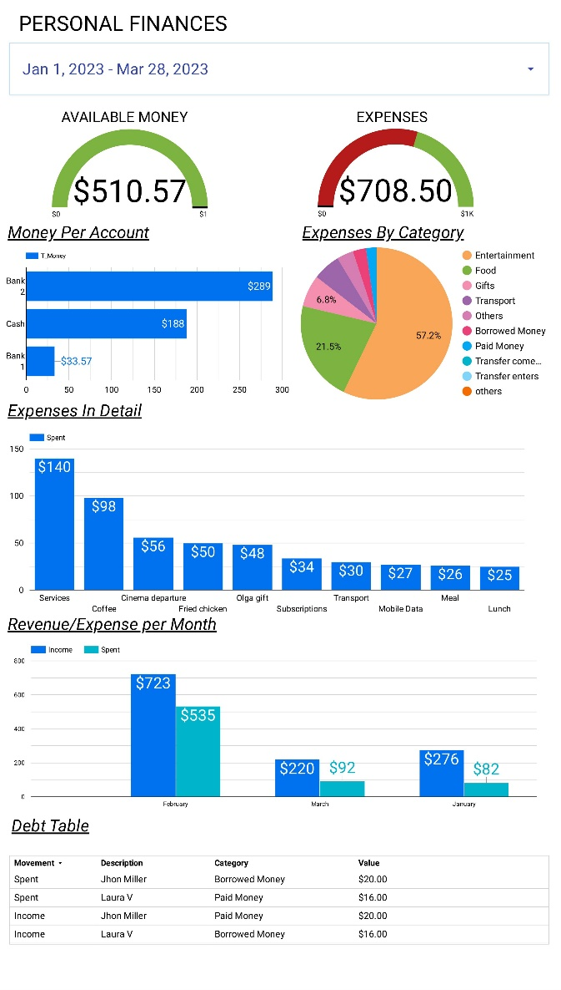

**Here are the questions I was interested in answering**

Which key performance indicators (KPIs) are of interest to the client?

Which tables need to be queried from the server to build the dashboard?

How can I create an environment for easy, daily updates in Google Sheets and Looker Studio?

How should I adjust variables to relate tables and create measures in Looker Studio?

What is the best way to arrange charts and select colors for a compelling visualization?

**I took the following steps to create my analysis**

Established connections with relevant information sources (Google Sheets)

Performed data cleansing using the most suitable environments, such as (Google Sheets)

Related tables and developed the necessary indicators.

Selected appropriate charts, as well as their placement and appearance.

Implemented the required actions in response to client feedback.

**Here are my takeaways**

Utilized the most suitable environment for creating indicators

Implemented measures to ensure that the environment allowed for simple daily updates.

Reviewed and selected the ideal charts and indicators to meet the client’s requirements.

Created a dynamic environment to facilitate interactive filtering and visualizations.